An Algorithm: Baking a Cake

Algorithm: A predetermined series of instructions for carrying out a task in a finite number of steps.
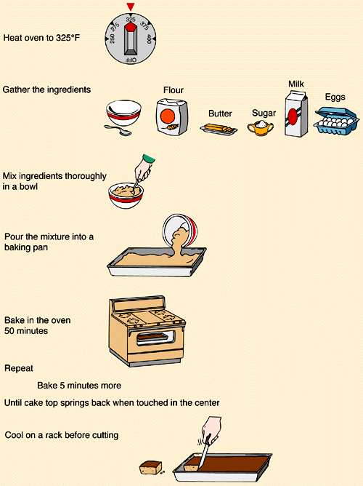

Flowchart Symbols

Flowchart: A graphic representation of an algorithm, often used in the design phase of programming to work out the logical flow of a program.


